

This brand is all about the attitude. The attitude of being alive and highly aware of the environment.
HOOLEY is the ‘younger’ brother of the brand Re-Sails. Re-Sails is the brand that takes old and unwanted yacht sails and develops them into bags and accessories. ( Schlebach brothers)
HOOLEY as a brand inherited the same ethos as Re-Sails, but targets a completely different spectrum of the market. HOOLEY takes material that is made redundant and no longer fills its initial purpose recycling it into functional and visually rich products! The redundant material is advertising billboard banner or ‘skins’ as the industry refers to it as.

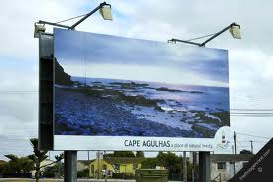
At Hooley headquarters based in Wood stock, a highly skilled and passionate team clean these skins and cut them into more manageable pieces. It is about this time that the magic starts to happen. The pattern pieces of the several of bags are laid individually and through a process of design the elements of a bespoke one off bag begin to take shape. The next step in the manufacture process is the construction of these individual bags. The skilled machinists at HOOLEY take it from here.
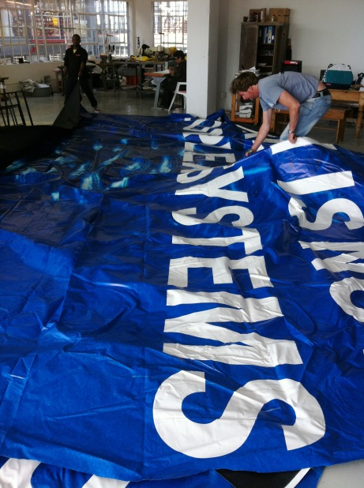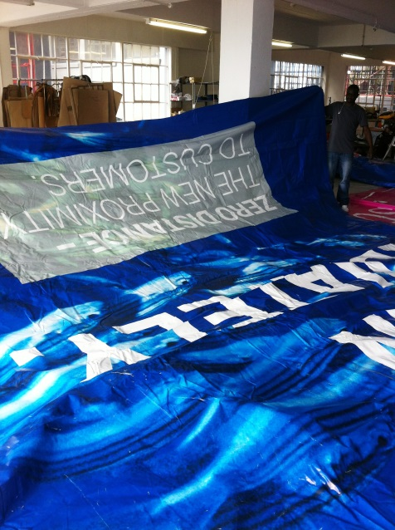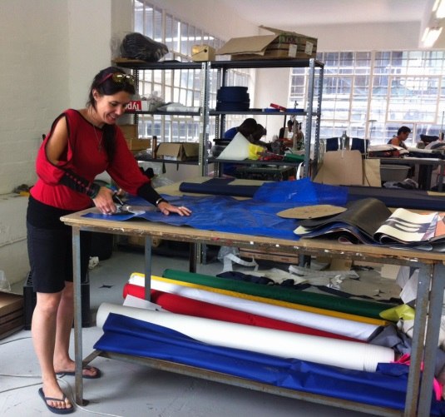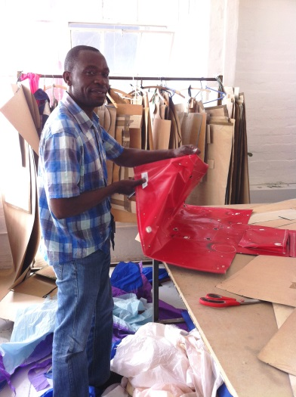
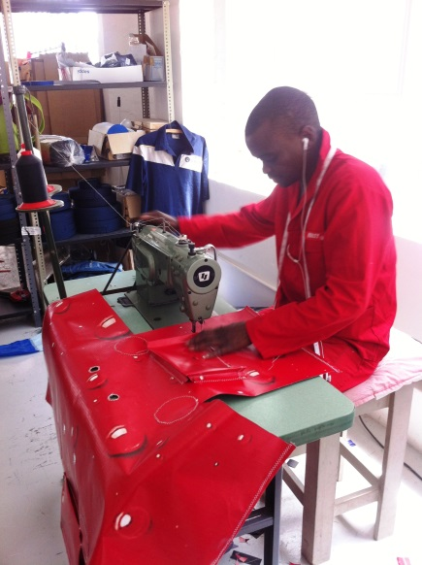All the prep work, everyone gets involved!
HOOLEY as far as recycling goes is not a new concept in South Africa. It is how HOOLEY uses the material in the recycling process that makes it unique and new. It is communicating with the average consumer and offering them a product that is as much of a sought after product as any made with less conscious design. The re-cycled aspect of the products available at HOOLEY is merely a bonus; it is the way in which the product has been constructed -thought in functional design. Everyone is jumping on the recycling wagon and it is no longer adequate to slap a recycled badge onto a product. The public now want the function in the product just as much as the recycled aspect.
HOOLEY as a recycled product is developing a name for itself in the young tail end of the market. The HOOLEY brand resonates with fresh minded, active, sucking the marrow from the bone individuals; who not only think about the environment but actively incorporate this thought into their everyday approach. The brand is edgy with designer function but without pretention. It is the uniqueness of every bag that awakens this attitude of personal style and eco-consciousness!
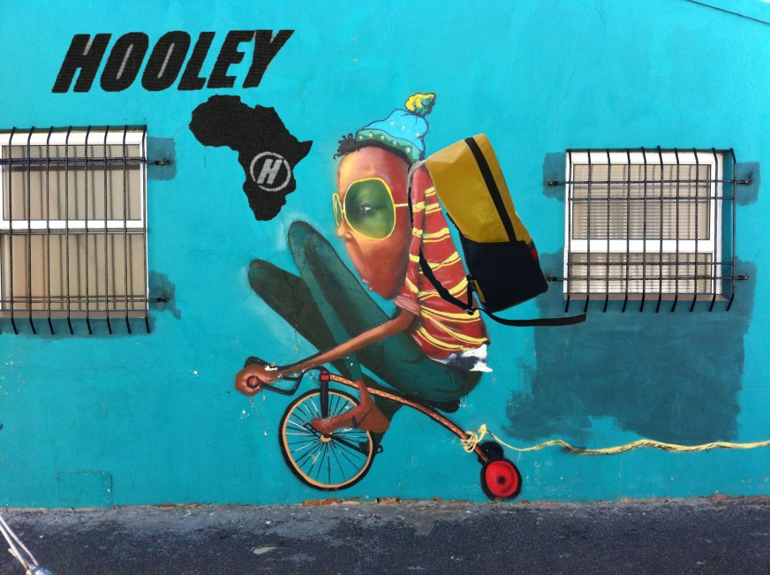 HOOLEY! Re-cycle, live, do it well!

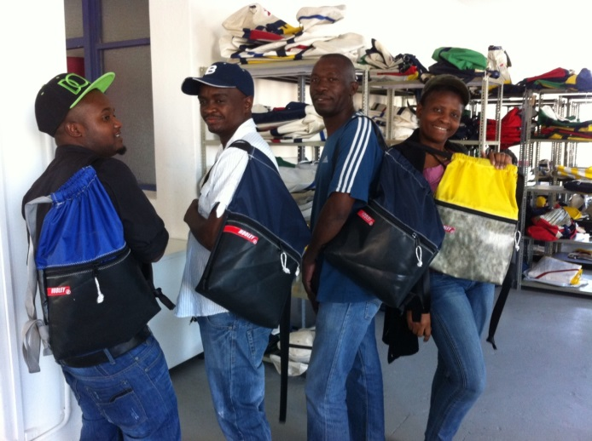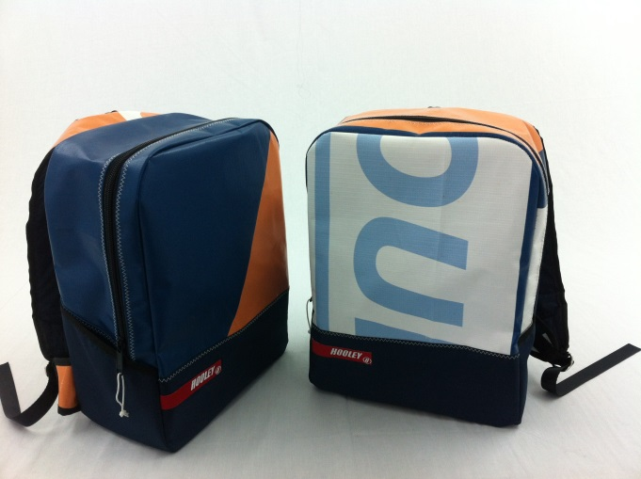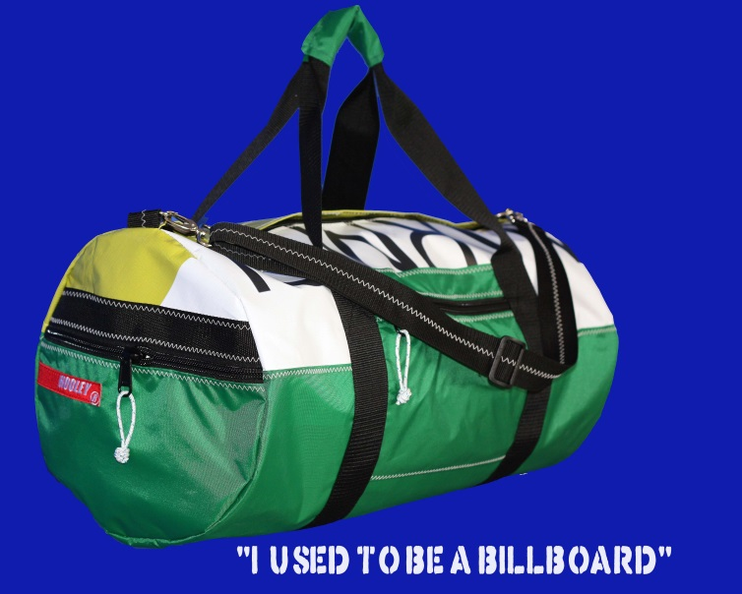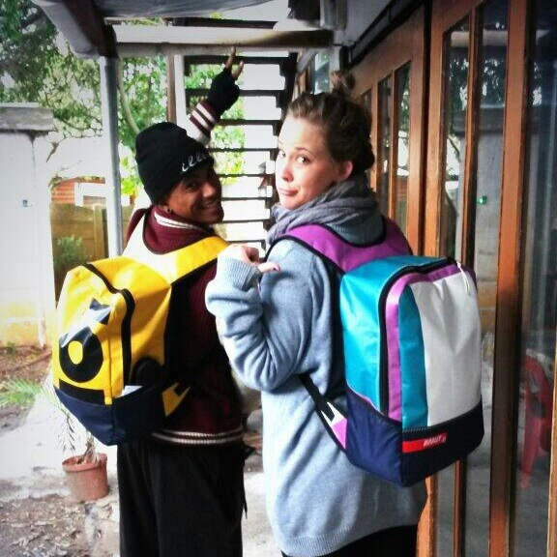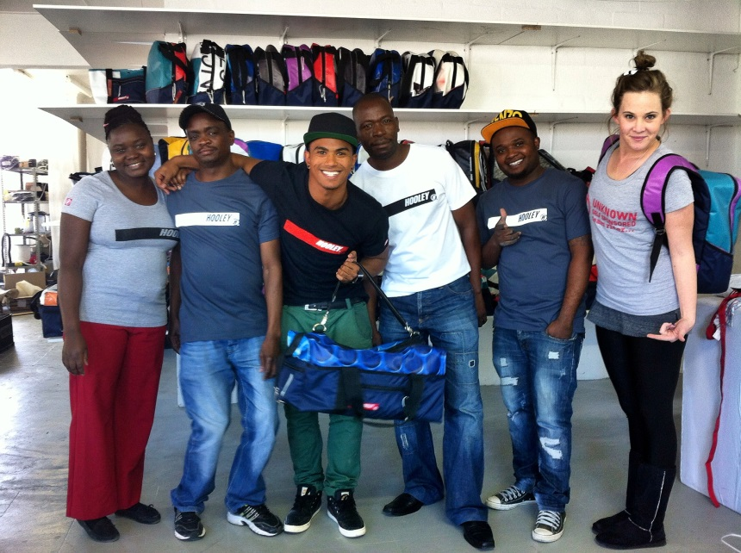Two dancers HOOLEY has endorsed (Cleo and Nate hanging out with the team at the Woodstock workshop)
MOVING FORWARD
HOOLEY as a young brand is opting for an organic growth, constantly learning and developing a personality through its peers. In this approach, open mindedness and opportunity in other wise unnoticed markets, has allowed HOOLEY to resonate with ambitious, eco-conscious pay it forward individuals. It is this slow and personal involvement in the brand that HOOLEY is developing a strong foundation from which to build a path into the future and do even greater things concerning the environment that ultimately affect the individual – closing the circle.
For now HOOLEY is endorsing young Dancers who are helping young disadvantage children to learn to dance keeping them off the street. Develop platforms for older dancers to gain exposure otherwise not available to them and to connect individuals who are like minded. These dancers have become mentors in an industry otherwise unknown to the HOOLEY team.
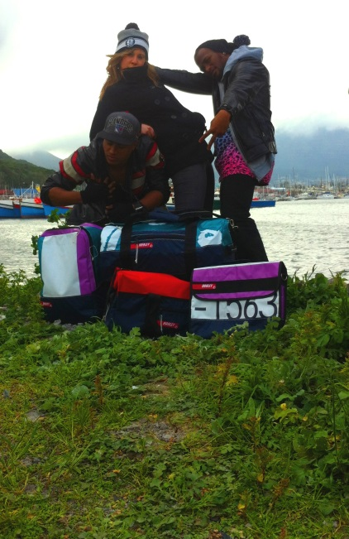
HOOLEY has worked alongside an individual who is working on an initiative with SOIL FOR LIFE to grow vegetables and other plants in disadvantaged communities – HOOLEY manufactured
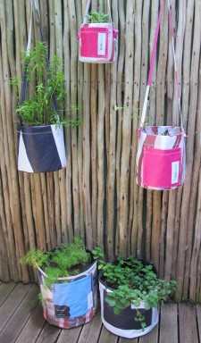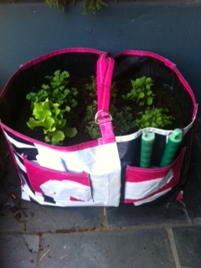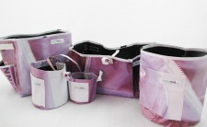

HOOLEY’s latest project - to donate Back Packs to a group of talented young musicians (AMA –Wolseley Marimba Band) who were spotted playing and have subsequently been invited to a food and wine festival in LA. Although it is a small contribution, it is the knowing that the young musicians will have a unique and recycled bag that has their individual personality stamped on it.
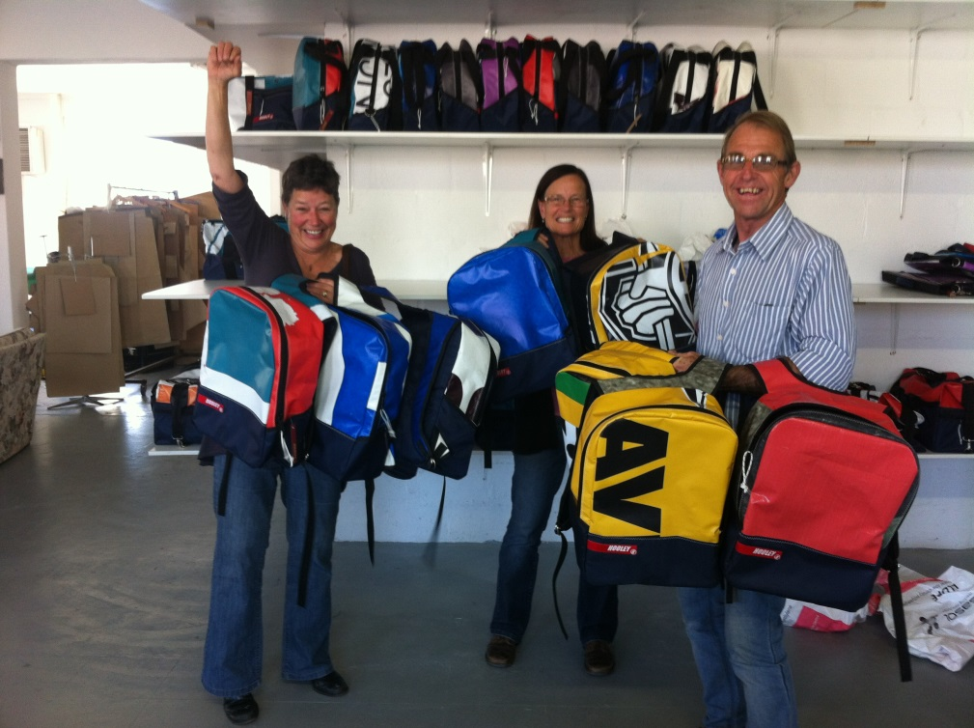
This to date has been the most up lifting project to be involved in. The giving without expecting which I am sure Peppe and Paul will agree with 100%. True dedication and hard work always pays off in some form or other.
So in short HOOLEY as a young brand has plenty of room to grow and to grow in the right direction
Re-cycle, live, do it well
www.hooley.co.za
@HooleySA
Hooley South Africa on facebook.

